The Dewditarod Camporee Challenge
Leader’s Guide 2012
Dear Scoutmasters,
Your Troop is invited to join the rest of the Coosa District at Camp Sidney Dew for our camporee. The Camporee Staff has put together an exciting and educational program that is suited for all levels of Scouting. The program will promote Scouting Skills and provide challenges for your Troop. Camporee’s also provided an opportunity for Scouts to fellowship with Scouts from other Troops. This is a fun and exciting event that your troop will not want to miss.
Camp Sidney Dew is located in the cold tundra region of North Floyd County, Georgia at the base of the awe inspiring and some would say majestic peaks of John's Mountain. The Dew, as it is affectionately called, is known for its wildlife, scum ponds, and the world famous Pompie Park, where you can rest your tired and weary bones. If you’ve never been there then you will certainly want to participate in this Camporee.
The Dewditarod Camporee Challenge. What does the theme mean? There is a history here. The name Dewditarod is a play on the word Iditarod, a famous dog sled race in Alaska. The following paragraphs were taken from the EnchantedLearning.com website.
The Iditarod is a dog sled race that takes place every March in Alaska. It is sometimes called the “Last Great Race.” Although the race is over 1150 miles long, the race is “officially” 1,049 miles long since Alaska is the 49th state. The Iditarod trail goes from Anchorage to Nome. There is a northern route and a southern route; these are used on alternate years ( north in even-numbered years). The race starts the first Saturday in March and takes about 10 days to complete. The winning musher takes home a large cash prize. The last musher to finish the race extinguishes and wins a red lantern at the finish line. The red lantern signals that there is still someone on the trail.
Hardy sled dogs pull the sled and musher across frozen rivers, barren tundra and steep mountains. The first Iditarod race was run in 1973 on the 100th anniversary of the purchase of Alaska by the United States from Russia. The dog sled race commemorates the “Great Race of Mercy”, a real race against time that saved lives threatened by disease.
In February 1925, a diphtheria epidemic threatened the isolated city of Nome, Alaska. The lives of many children in Nome were threatened by this terrible disease, especially those of the native Inuit children, who had no previous contact with diphtheria, and therefore no immunity to it. The only way available to save the children was to transport the medicine 674 miles across land form Nenana, near Anchorage, to Nome using dog sleds. Twenty teams of mushers and over 100 dogs delivered the medicine to Nome in about 5 ½ days.
The lead dog of the final team of dogs was Balto, who become quite famous; the lead dog of the teams that braved the toughest and longest part the journey was called Togo. A movie has been made about Balto and his stuffed remains are on display at the Cleveland Museum of Natural History. As for Togo, we don’t know what became of him. The word Iditarod comes from an Athabaskan Indian word pronounced “Hi-dit-a-rod.” It means distant place.
STAFF: Participating troop leaders are required to help staff the challenge events at the camporee. Please coordinate with Bill Davis regarding your Troop’s activity assignment (706-506-7423 or wdavis0895@comcast.net). The challenge staff members will work in shifts to allow each one time to observe their own scouts throughout the day. Score sheets will be given to the challenge staffers which they will use to evaluate and score the patrols. Honor system is in effect.
WHAT IS YOUR CHALLENGE? A disease of epidemic proportions has spread across Camp Sidney Dew. Your patrols goal is to carry the serum that is needed to cure the disease and save the sick. The “serum” will be a raw egg that is to be protected and delivered safely and unbroken to the designated check in station. Eggs will be provided
YOUR TEAM will consist of a musher, reporter, activities director, one or two lead dogs, one or two wheel dogs, and a veterinarian. The musher will be the team leader. The veterinarian will be in charge of the “serum” and the dogs. The dogs will transport the cart with your teams supplies. The activities director job will be to make sure that the team completes the challenges along the way, and the reporter will interview the musher at WCSD radio. While the interview is taking place, the vet and activities director will look after the dogs. Some sled teams may have to double up on the duties and responsibilities, such as having one scout to be both the vet and musher, etc.
EQUIPMENT FOR THE RACE:
Wagon: each team/patrol will need to bring a cart, wagon, or wheel barrel to transport their gear and serum safely over the course and to the designated check in station. The wagon will act as the patrol’s sled.
Patrol Gear: Each scout will need to have a daypack or fanny pack to carry their gear. Their gear will include the ten Scout basic essentials as listed on page 264 of the BSA handbook, plus the following: a bandana, one hiking stick per scout, and one piece of 3/8 inch rope that is six feet in length per scout . The gear needs to be secured to the wagon using rope or other means so that it does not off or out. Your patrol members will not be allowed to carry their gear. It must be transported in the wagon. You will also need a way to protect the “serum” from breaking. You will also need to bring a sack lunch for Saturday which will be eaten on the Dewditarod race course.
CHALLENGES AND ACTIVITIES:
Sharp Shooter:
Location: Rifle Range. Choose four scouts as your Patrol’s sharp shooters. Eachs scout will have five shots. BSA rifle range rules apply. There will be a shooting sports director to maintain standards and BSA compliance. This will be a scored event.

Robin Hood:
Location: Archery Range. There will be three targeted distances. Your patrol must decide as a group which distance they want to shoot. Target # 1 (15 feet ),average score of scouts x 1. Target area #2(25 feet). Average score of scouts x 2. Target # 3 (35 feet), average score of scouts x 3. This is a scored event. Four scout limit.
Lite My Fire:
Location: Blackfoot Shelter Area
Patrols will need to gather their own fire starting materials from camp. No materials can be gathered prior to the Camporee Director’s starting time. Patrols will need to build a fire to boil a pint of water in a pot. Pot and grill will be provided. This is a timed event. Leave No Trace Principles for camp fires will be the standard.
Dog House Challenge:
Location: Scout Craft
Your dogs are tired and need to rest. It is cold outside and they need shelter from the weather while they sleep. Your patrols challenge is to build a shelter that will protect your dogs, and then take it apart. Timbers and rope will be provided for this challenge. This is a timed event.
Reyado Challenge:
Location: Athletic Field
Step back in time and test your Patrol’s knife throwing, saw cutting, and Atlatl hurling skills. Choose your three best knife throwers to hurl three knives at a target set 15 feet away. Then choose your three best men to saw a log into three pieces. Then choose your three best Atlatl throwers to hurl five arrows at a target that is 45 feet away. Knives, saws, atlatls and arrows will be provided. Knife throwing and atlatls will be scored events. Saw cutting will be a timed event.
Live from WCSD Radio:
Location: Pool
Test your Patrol’s communication skills. Choose one scout to be the interviewer/reporter and one scout to be the musher/interviewee. The reporter will engage the musher in a one on one interview in which he will ask thought provoking questions to reveal the musher’s thoughts and ideas about the race up to that point. This is a scored event. Both the reporter and musher will be judged for points.

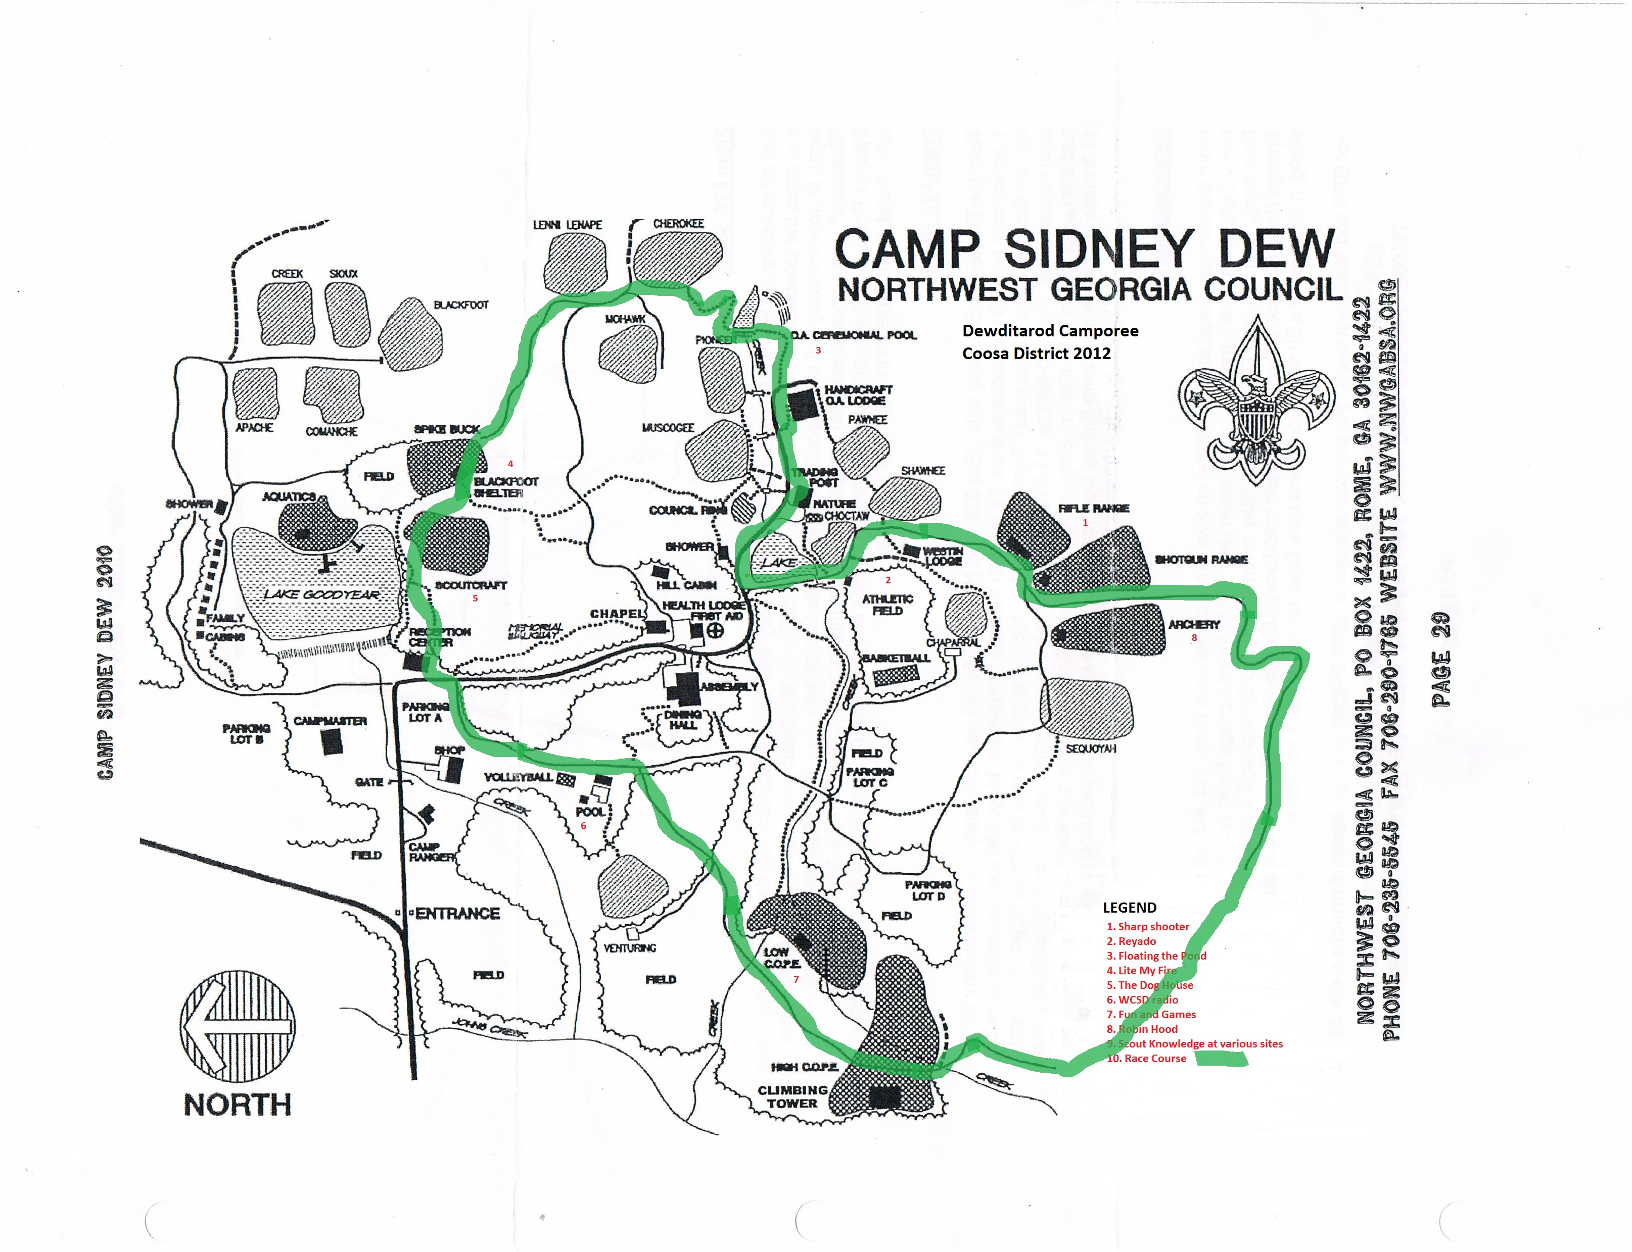Floating the pond:
Location: OA Pond
Patrols must use proper lashings to construct a raft to ferry their wagon, gear and serum safely across the water. Patrol members will cross the water via the dam. Once the gear and wagon are safely across, the patrol will disassemble their raft for the next group’s use. This is a timed event. All materials will be provided for this challenge. Do not let your wagon fall off the raft.
Team Building:
Location: C.O.P.E.
Patrols will compete in five of these seven team building activities: Zulu toss, Brown Sea Island, Log Jam, Trolley, Mafeking Message Machine, Wiggle Woggle, and/or Nail Biter’s nightmare. This is a timed event.
Scout Knowledge:
Location: Various venues
Throughout the race, your patrol will be given a chance to answer questions about your scouting knowledge. The questions will not only cover basic scout knowledge from tenderfoot to first class, but also will test your knowledge about other aspects of scouting. This will be a scored activity.
Summary
Along the way, your team will face many challenges. These challenges may include but are not limited to carrying your gear and serum over a course at least three miles long; gathering food at the rifle and archery ranges; traversing the tundra ate the Athletic, C.O.P.E., and Blackfoot Fields where your team will build a shelter to protect them from the brutal cold north winds, answer scout trivia questions to move on, and/or play team building games; build a raft so that you can ferry your gear and the serum across treacherous waters; climb steep mountains with a single bound; make fires to keep yourself and the dogs warm, demonstrate knowledge of basic first aid, and finally deliver the serum to the designated checkpoint.
THE WINNER will be the team with the fastest overall time. This time will be based upon how long it takes the team to traverse the course plus bonus time points less penalty time points. At the end of the Dewditarod, there will be a campfire for all to enjoy. Bonus points will be awarded for the following: teams that build their wagons, correctly answer scout trivia and first aid questions, use of correct lashings to build the shelter and raft, keeping your egg intact, keeping your patrol together till the end, high scores at the rifle and archery range, and how well your team does at the WCSD radio interview, and fire building.
Penalties will be given for answering questions incorrectly, missed targets at the rifle and archery ranges, and incorrectly tied lashings for your shelter and raft, not completing the course within the allotted time, breaking your egg, not having the ten essentials for the humans, not having "dog" food, and skipping a challenge. There will also be awards for spirit, best decorated wagon, and best designed wagon. The camporee director can also award bonus points and give penalties for things not listed above.
The camporee staff recognizes that your team may tire along the trail and that some scouts may want to drop out. With that being said, your team must finish with four scouts to be considered for awards. Teams that drop below four scouts will be asked to leave the race and root for the other racers. At the Iditarod, the dogs get tired along the way and retire from the race. We will honor this tradition at the Dewditarod. Once again, your team will consist of five to eight scouts. If your patrol does not have enough scouts to form a team, the staff will combine you with other patrols to make a team.
The Camporee Staff is committed to providing a quality program to your Patrols. We hope to see you there. Enclosed is additional information for your review. If you should have any questions or concerns, please contact me.
Yours in Scouting,

Bill Davis
706-506-7423 cell
wdavis0895@comcast.net

Note: Activity venues are subject to change.

Dewditarod 2012 Activity Schedule
Friday, December 7
Check-In & set up camp 5-8 PM
Welcome to the Dewditarod 8-9 PM
Scoutmaster & SPL Cracker Barrel 9-10 PM
Free time 10-11 PM
Lights Out 11:00 PM
Saturday, December 8
Wake Up 6:30 AM
SPL & Scoutmaster Breakfast 7 – 8 AM
Flag Ceremony 8:15 AM
Begin the Dewditarod Journey 8:30 AM – 12:00 PM
Lunch 12:30 – 1:30 PM
End the Dewditarod Journey 1:30 –2:45 PM
Camp Wide Activity 2:45 – 5:30 PM
Dinner 5:30 – 8:00PM
Campfire 8-9:30 PM
Free time 9:30-11 PM
Lights Out 11 PM
Sunday, December 9
Breakfast 7 – 8 AM
Flag 8:15 AM
Interfaith Service 8:30 – 8:45 AM
Awards 9:15 AM
Check Out After awards.

General Information
Awards!!!!!
What’s a Camporee without awards?
Awards will include but not be limited to; top three finishers of the Dewditarod challenge, outstanding spirit, best radio interview, and best sled design. Finally, we will have an award for the overall best team. This will be determined by the cumulative scores of all activities. Each event will have an award suitable for display..
Food!!!!
There will be a Scoutmaster & SPL Cracker Barrel schedule for Friday night after the opening ceremony and welcome. There will be an SPL & Scoutmaster breakfast on Saturday morning. If your SPL can’t attend please appoint a youth leader to act as SPL for the weekend.
Other than these two food events, Patrols/Troops will be responsible for their food for the weekend.
Free Time
Each Troop should have some free time during the day. You may sit, relax, go fishing, or play games. The scouts will also be able to help with a small service project. Ranger Bill will be the director for this activity.
First Aid
First Aid will be available at the infirmary. However, each Troop should be able to take care of minor injuries. Injuries requiring medical attention should be reported to and attended by the staff. All scouts, adult leaders, and staff must bring a BSA med form with them. If you forget, we will have them available at camp. We will have trained medical personnel on staff for this Camporee.
Permission Slips
Every Scout should have a permission slip signed by their parents/guardians giving permission for any medical treatments, hospital visits, etc. These forms should be kept in the campsite and be readily accessible in the event of an emergency.
Campsites
We will assign campsites based upon troop size and needs. Some sites may have more than one troop, so be prepared to share.
UniformsScouts should be in Class “A” uniforms upon arrival, at worship services, Flag Ceremonies, and during the campfire program. During the day on Saturday Scouts may dress in either Class “A” uniforms, or Troop tee-shirts. Patrols should dress consistently.
Fees
The cost for the Camporee this year is $12.00. This includes camp fees, prizes, cracker-barrel, awards, and other assorted supplies and equipment. Not too bad for a great weekend. Early bird discount is $8.00, see the registration information. Early bird by November 15th; deadline is Nov 30th.
Camporee Prep Day:
For all that are interested, we will meet at camp on December 2 for set up. Bonus points will be given to those teams that help with preparation. Just showing up does not count.

Saturday Arrivals
It’s football season so Saturday arrivals are inevitable. We will let the Scout Leaders manage any Saturday arrivals in their own units. You will need to meet the scout or leader at the gate and walk them in. If you need assistance please contact the camp staff. We do ask that we don’t have any vehicles moving on the road after Friday check in. Any Saturday arrivals should either send their gear with the Troop or plan to pack it in. Thank you for your help with this.
Directions:
Go to nwgabsa.org and follow the link to camps. From there, click on camps and follow the link to Sidney Dew. Directions are at that site. You can also google or mapquest them.

Camp Policies
The following rules are made to help us have a successful and safe camping experience. It is the responsibility of the adults in charge to see that their Scouts know and understand these rules.
Vehicles: Speed limit is 10 mph
No passengers in back of truck or trailer. You may bring in a Troop trailer or one gear vehicle to the campsite. After dropping the trailer or unloading the one gear vehicle you will be asked to move your vehicles back to the parking area. Ranger Bill will have the final say about troop trailers at camp sites. If you don’t have a troop trailer or one gear vehicle, haulers will be available Friday to take your gear to camp. On Sunday, gear will be picked up before and after the Interfaith Service. No gear will be picked up during the interfaith service. Plans as of right now are to use Hubbs as our parking lot.
Fires: Campfires are allowed in designated spots unless there is a ban issued.
NO CAMPFIRE MAY BE LEFT UNATTENDED!! NO FIRES OUTSIDE OF FIRE RINGS!!
Firearms: Firearms, explosives, and fireworks are prohibited.
Conservation: Please conserve our natural resources. No digging, trenching, or raking.
Adults: At least one responsible adult (21 or older) must be in camp at all times, with a minimum of 2 adults.
Knives: NO straight bladed knives are allowed in camp.
Lights out: Scouts are not allowed out of their site after lights out with the exception of to and from the latrine.
PLEASE respect others during lights out. If this is an issue and the Camp Staff is able to assist, please let us know.
Radios: No radios, stereos, tape players, headsets, ipods, itouch, cell phones, etc. are allowed in camp.
All other BSA and Camp Sidney Dew rules apply.

2012 Coosa District Fall Camporee Registration Form
See Next page for Pre-Registration Form, please bring this form with you to campout. It should be filled out and turned in by the end of the cracker-barrel Friday night.
Troop
Scoutmaster SPL
Patrol Names:
1) | 2) | 3)
Scouts:  a) | a) | a)
b) | b)
 | c) | c)
d) | d) | d)
e) | e) | e)
f) | f) | f)

g)_____________________g)_____________________g)
h) h) h)
i) i) i)
j)______________________j)_____________________j)
Adults:
1 | 2 | 3
4 | 5 | 6
7 | 8 | 9

Total Participation Total Paid:
Registration Fee $12.00
Total Due Total Refund

2012 Coosa District Fall Camporee Pre-Registration
Form
This form is to be sent via mail to the BSA Rome Service Center attn. Kelly Meacham or emailed to me at wdavis0895@comcast.ner prior to November 30th. This is the deadline for registration. All fees need to be paid by November 30th . Please contact Tom Melton with any concerns.
Troop
Scoutmaster
Estimated # of boys
Estimated # of Adults
Total amount pre-paid for the Camporee ($8.00 early registration)_____________
$12.00 for late registration____________________________________________
Refunds will be made thru the Scout Office if the expected attendance is not met.
Forms and checks should be mailed to:
Rome Service Center
100 E. 2nd Ave., Suite 10
Rome, GA 30161
Attn. Kelly Meacham
CAMPSITE INSPECTION CHECKLIST
Coosa District Camporee October 2012
Troop
Points (0-5 each)
1. GENERAL CAMPSITE
- Troop and U.S. flags at camp entrance; properly displayed ___/5
- First Aid Kit available & visible ___/5
- No evidence of electronic games or entertainment devices ___/5
- Clean, neat, and orderly - free of litter ___/5
2. CAMPFIRE
- Fire area free of debris (minimum 10 ft.) ___/5
- Fire area is safe distance from tents (minimum 15 ft.) ___/5
- Water or sand available for emergencies ___/5
- No unattended fires ___/5
- Tools stowed properly ___/5
3. COOKING / DINING AREAS
- Duty rosters posted ___/5
- Propane/fuel stowed properly ___/5
- Perishable food stored properly ___/5
- Proper sanitation procedures in use ___/5
- Garbage stored properly ___/5
- Area clean, neat, and orderly - free of litter ___/5
4. TENT AREAS
- Tents set up in orderly manner ___/5
- Camping by patrol evident ___/5
- Tents set up properly (Stakes & Poles) ___/5
- Tents closed - gear stowed properly ___/5
- Area clean, neat, and orderly - free of litter ___/5
TOTAL SCORE ___/100

Patrol Spirit Award:
This will be monitored thru the day by the Camporee Staff. This is an example of the judging at the events. There will also be “caught ya doin something good” points that can be awarded by any Scout Leader or staff member. I.e. a patrol stopped to pick up some trash on the trail.
 | Patrol Flag Present | 5 points
 | Patrol Yell | 5 points
 | Spirit of Cooperation | 1-5 points
 | Polite (yes sir – no sir) | 1-5 points
 | Matching Uniform | 1-5 points
 | Good Attitude | 1-5 points
 |  | Total Points

Caught ya doin’ something good
Please turn into event staff no later than campfire on Saturday Night.
Patrol Name
Troop Number
What they were caught doing:
Points 1-5.

•

