2013 Fall Session - National Youth Leadership Training
Northwest Georgia Council

What is NYLT? National Youth Leadership Training (NYLT) is a six-day outdoor training course for senior youth leaders in the Boy Scouting or the Venturing programs. This fall session will be held on two three-day weekends. NYLT augments the training received from Troop Leadership Training (TLT) or the Introduction to Leadership Skills for Crews (ILSC) focusing on the skills needed by Senior Patrol Leaders, Presidents, and Boatswains. The course is led by a volunteer staff of youth and adults experienced in training youth leaders.

Is NYLT like Summer Camp; are merit badges available? No, NYLT is NOT for rank advancement or earning merit badges. It is leadership training in an outdoor setting. Because NYLT is an intensive training experience, participants should possess sufficient maturity, judgment and leadership potential to successfully complete the program. Each participant will be evaluated during the course on their Attitude (Be), Knowledge (Know) and Skills (Do).

What is its purpose? The purpose of NYLT is to support the training of the senior youth leaders in your unit, not replace it. This training builds on the lessons in ILST and ILSC (formerly VLSC). Some of its objectives are:

• To focus on the concepts of what a leader must BE, what he must KNOW, and what he must DO.
• To emphasize immediate application of learning in a fun environment.
• To model a month in the life of an “ideal” unit.
• To provide each participant with a toolbox of leadership skills.
• To operate according to the Scout Oath and Law.
• To have fun!

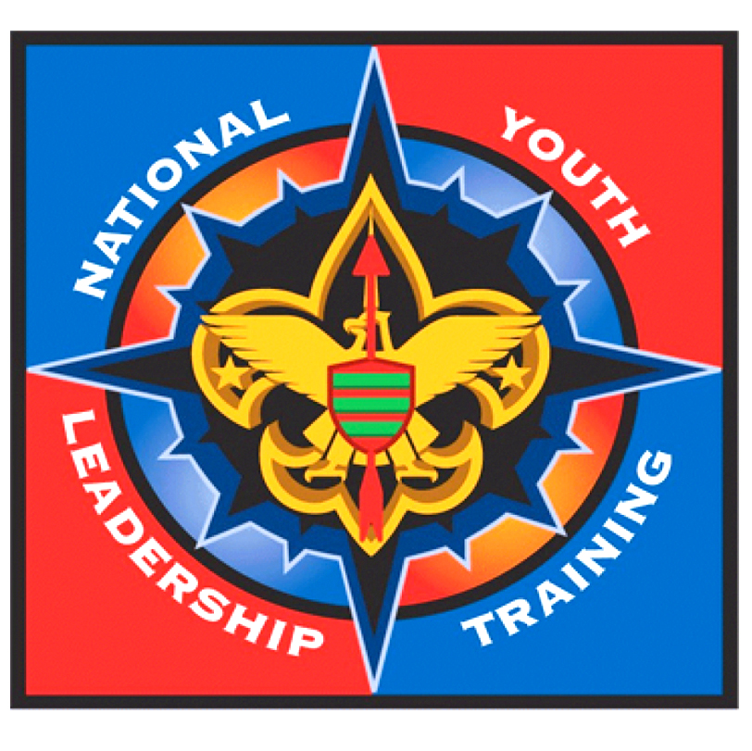
Who may attend? NYLT participants must be at least 13 years old, have at least one week-long camping experience, and have been in Scouting for a minimum of one year before the course begins. Participants must also be proficient in camping and cooking skills and for Boy Scouts, have mastered the skills required for First Class and attained that rank. Scouts should also be currently serving in a senior leadership positions within the unit (SPL, Pres., B'sun and their assistants) or likely to do so in the near future.

What do I need to bring? Your regular Boy Scout or Venturing field uniform is the official uniform of NYLT. You will also need gear for a weekend of camping. You will receive a detailed equipment list upon registration. Food and cooking gear are provided as well as a T-shirt, hat, pen and notebook. NYLT is operated in accordance with the National Health Standards of the Boy Scouts of America. All participants must be approved by their doctor within one year prior to the start of NYLT, using the Annual Health and Medical Record form and bring it with them to registration. A participant will not be allowed to begin the course without a current Annual Health and Medical Record form on file.

What is the cost? The cost of the course is $225.00. A $50.00 deposit will reserve a place in the course until August 1, 2013, then full payment and a completed application form are due. Attendance is limited to 48 Scouts; if more reservations are received, the first 48 acceptable applications with full payment will be chosen. Deposits will be returned to Scouts who are not accepted.

Because of the benefits of this training to the unit, it is highly recommended that the unit consider paying part or all of the participant’s fee. Make checks payable to: Northwest Georgia Council, B.S.A. You can submit applications and payments by mail or at either Scout Office:

Northwest Georgia Council, B.S.A Rome Dalton
P.O. Box 1422 100 E. 2nd Ave., Suite 20 202 S. Hamilton Street
Rome, GA 30162 Rome, Georgia 30161 Dalton, Georgia 30720
Phone: 706-235-5545 Phone: 706-272-7111
Fax: 706-290-1765 Fax: 706-370-4111

If you have any questions about NYLT please contact:

Tom Melton, Fall Session Course Director cell phone (770) 630-2617 email: tmelton729@gmail.com
Alex Brumfield, Assistant Course Director cell phone (205) 288-1814 email: cabrumf@gmail.com
Kelly Meacham, Staff Advisor cell phone (706) 235-5545 email: kmeachem@bsamail.org

