Application for an Invitation to Participate in NYLT

Fall Session is held at Camp Sydney Dew, 3624 Everett Springs Rd Armuchee, GA 30105
Weekend #1: 9:00am Sat 31 Aug 2013 – 4:00pm Mon 2 Sept 2013
Weekend #2: 9:00am Sat 12 Oct 2013 – 4:00pm Mon 14 Oct 2013

SCOUT:

Name___________________________________________________________ Nickname _______________________________

Address__________________________________________ City_______________________ State______ Zip_______________

Phone ( )_______________________ Age_______ Gender: Male □ Female □  School Grade ________

Rank/Award__________________________ Unit Position_____________________________ Years In Scouting _______

Unit: Troop □ Crew □ Ship □ #_________ District (or Council if outside of NWGA)______________________________

Identify any Food Allergies or Dietary Restrictions:_______________________________________________________________

Email___________________________________________________ May we send E-mail instead of regular mail? Yes □ No □

Adult T-Shirt Size (Circle One) S M L XL XXL

Explain briefly why you want to attend NYLT and what you expect to gain ____________________________________________

_________________________________________________________________________________________________________

_________________________________________________________________________________________________________

_________________________________________________________________________________________________________

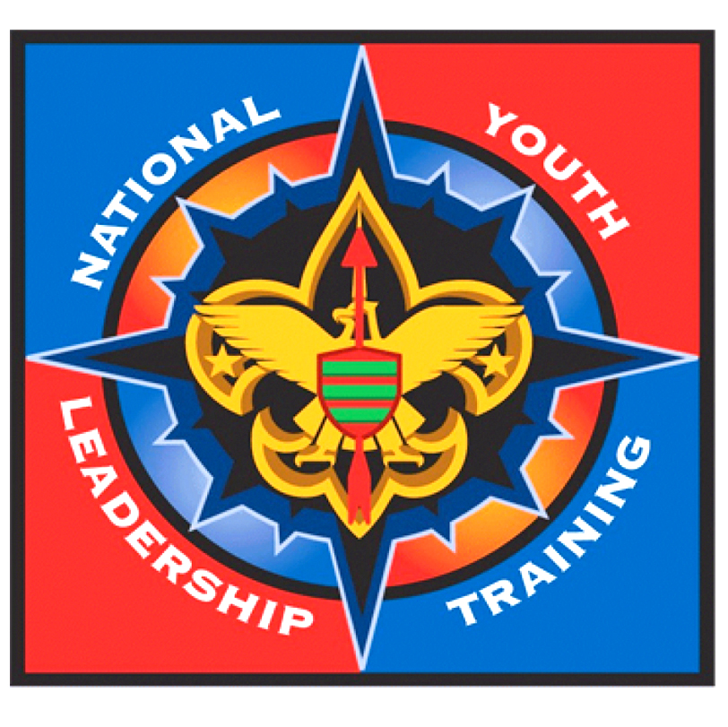
On my honor as a Scout, I will faithfully live and act the Scout Oath and Law while I attend NYLT. I further promise to represent my Unit with honor and promise to pass along my new skills and knowledge to the other members of my Unit when I return from NYLT. I have provided this information to the best of my ability. I have read the NYLT Uniforming Policy and Mandatory Personal Equipment List and agree to comply with all these requirements. I understand that I should arrive at camp on time and may not leave camp during the course. I understand that I can be sent home if I do not follow these policies.

Scout's Signature_____________________________________________________ Date: ________________

SCOUTMASTER/ADVISOR/SKIPPER:

Name:__________________________________________________ Phone ( )_______________________

Email: _____________________________________________________

I affirm that the Scout I am nominating to attend NYLT will be at least 13 years old by the start of the course and has the maturity to benefit from the course. This Scout is currently serving in a senior leadership positions or expected to be doing so shortly. He/she is proficient in camping and cooking skills and if a Boy Scout, has mastered all of the skills of a First Class Scout and has attained that rank. He/she has completed Troop Leadership Training, or the Introduction to Leadership Skills for Crews, or will do so before the course starts. I have read and reviewed this Scout's application and find the information to be accurate and complete.

Unit Leader Signature: ________________________________________________ Date: _______________

Record of Payments (Total Cost - $225)

Deposit ($50.00 min.) .................................. $______________
Final Payment (Due by 08/02/2013) .............. $______________
Total Paid .................................................... $______________

