Scout & Leader Agreement

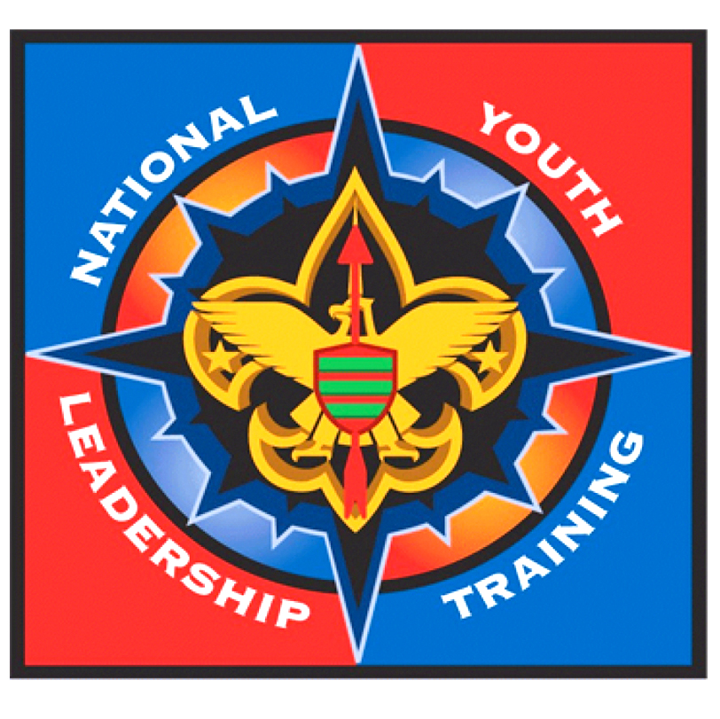
On my honor as a Scout, I will faithfully live and act the Scout Oath and Law while I attend NYLT. I further promise to represent my Unit with honor and promise to pass along my new skills and knowledge to the other members of my Unit when I return from NYLT. I have provided this information to the best of my ability. I have read the NYLT Uniforming Policy and Mandatory Personal Equipment List and agree to comply with all these requirements. I understand that I should arrive at camp on time and may not leave camp during the course. I understand that I can be sent home if I do not follow these policies.

Scout's Signature_____________________________________________________ Date: ________________

SCOUTMASTER/ADVISOR/SKIPPER:

Name:__________________________________________________ Phone ( )_______________________

Email: _____________________________________________________

I affirm that the Scout I am nominating to attend NYLT will be at least 13 years old by the start of the course and has the maturity to benefit from the course. This Scout is currently serving in a senior leadership positions or expected to be doing so shortly. He/she is proficient in camping and cooking skills and if a Boy Scout, has mastered all of the skills of a First Class Scout and has attained that rank. He/she has completed Troop Leadership Training, or the Introduction to Leadership Skills for Crews, or will do so before the course starts. I have read and reviewed this Scout's application and find the information to be accurate and complete.

Unit Leader Signature: ________________________________________________ Date: _______________

Record of Payments (Total Cost - $225)

Deposit ($50.00 min.) .................................. $______________
Final Payment (Due by 08/02/2013) .............. $______________
Total Paid .................................................... $______________

